Version 1.0

Revision History

|  |  |  |  |
| --- | --- | --- | --- |
| **Date** | **Version** | **Description** | **Author** |
| 12/12/2019 | 1.0 | details | Tran Van Dat |
|  |  |  |  |
|  |  |  |  |
|  |  |  |  |

Table of Contents

1. Use-Case Name 3

1.1 Brief Description 3

2. Flow of Events 3

2.1 Basic Flow 3

3. Special Requirements 3

4. Preconditions 3

5. Postconditions 3

6. Extension Points 3

# Use-Case Name

## Brief Description

This use case helps admin logs out or quits account from system when he/she doesn’t want to access computer shop system.

# Flow of Events

## Basic Flow

The first step is that admin selects log out button in system. After that, system will log out admin’s account and display a message for logging out successfully. This process ends.

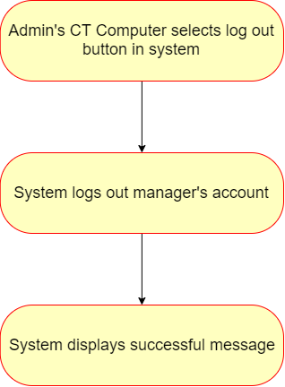

# Special Requirements

None

# Preconditions

Admin need to log in system

# Postconditions

System backs to log in page.

# Extension Points

None